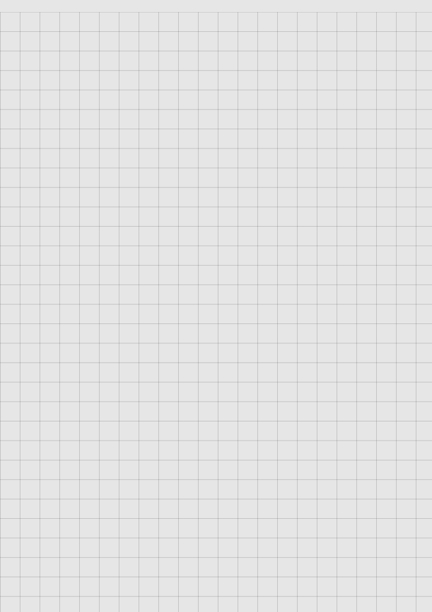

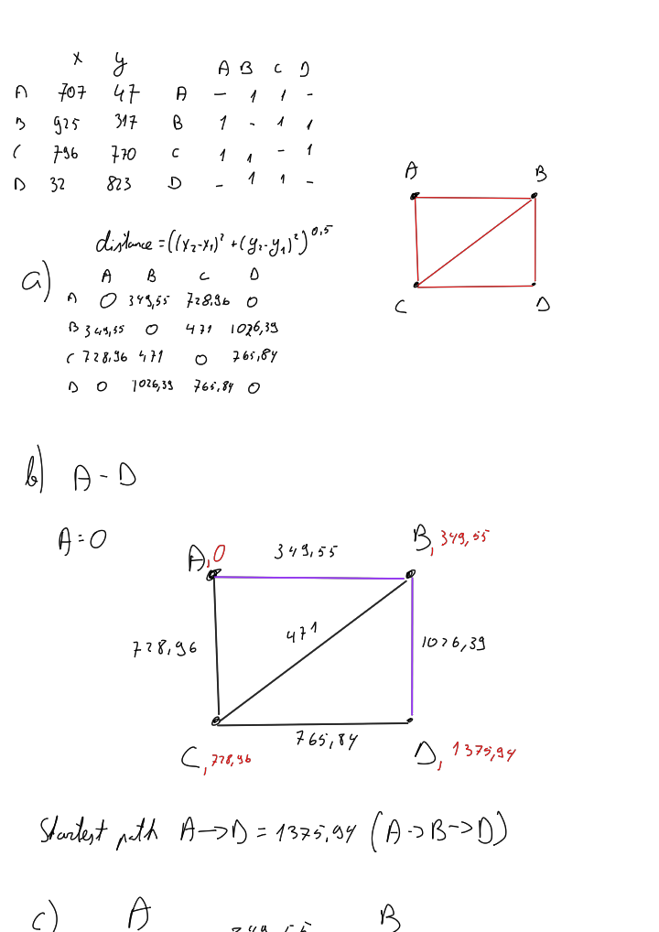

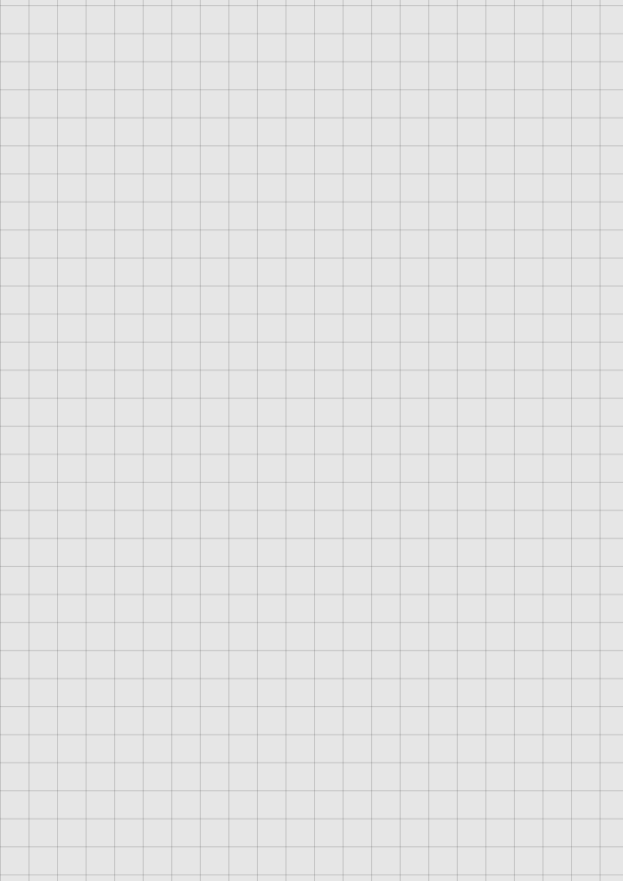

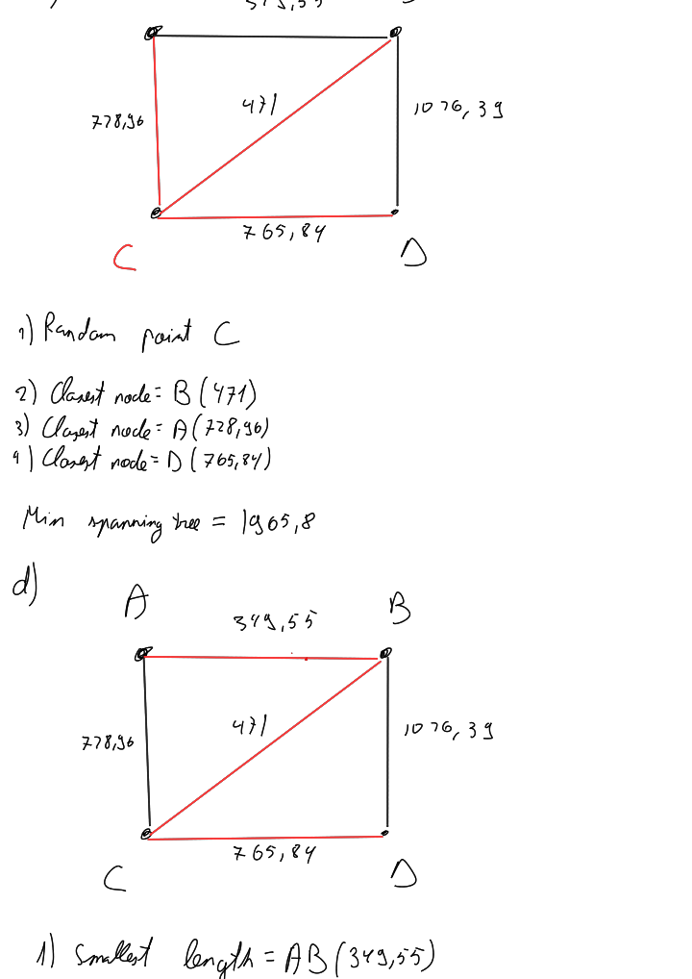

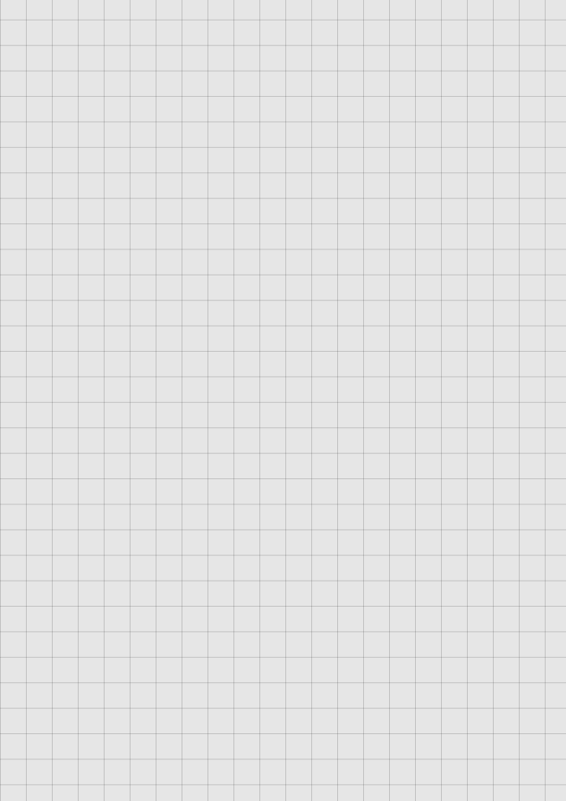

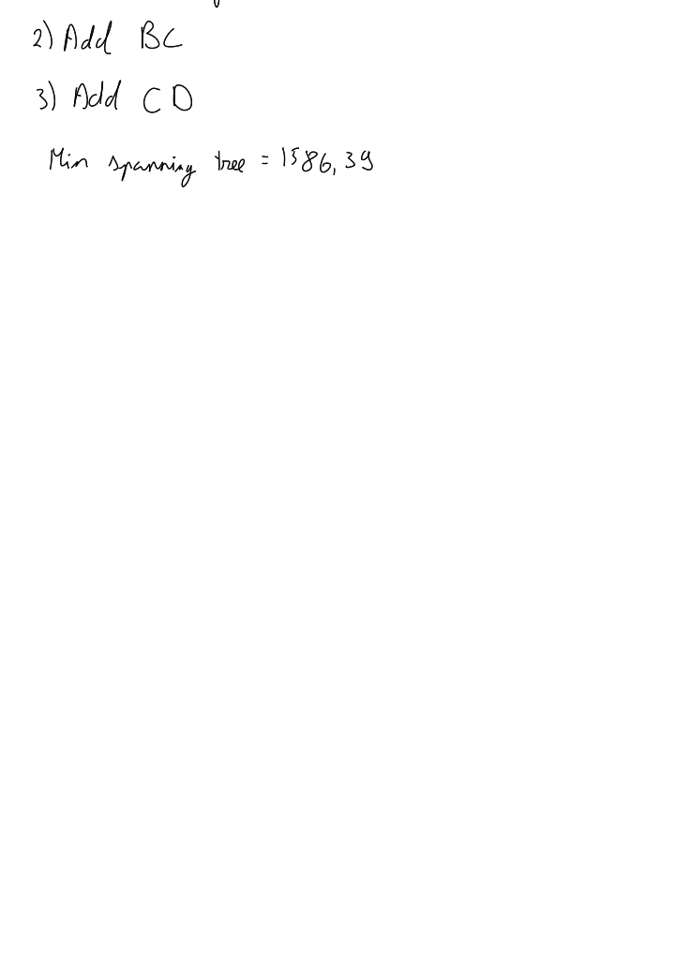

import numpy as np

import csv

def fetchcsv(filename):

    # using the NumPy library to read a CSV file and convert it into a NumPy array of integers.

    r = np.genfromtxt(filename, delimiter=",", dtype=int, names=True)

    #

    # This code is reading a CSV file and converting it into a numpy array of strings.

    reader = csv.reader(open(filename, "r"), delimiter=",")

    x = list(reader)

    result = np.array(x).astype("str")

    Labels = []

    # Delete the first element of the array which is the labels

    for i in range(len(result[0])):

        Labels.append(result[0][i])

    del Labels[0]

    dictionary = {}

    keys = []

    values = []

    # retrieves the corresponding values from the Labels list and appends them to the keys list.

    for i in range(len(r[0]) - 1):

        keys.append(Labels[i])

    temp_dic = {}

    sub_keys = []

    sub_values = []

    # Iterate over the rows of the matrix

    for j in range(len(r[0]) - 1):

        # Iterate over the rows of the matrix

        for i in range(len(r[0]) - 1):

            # Check if the value at position (j, i+1) is not equal to -1

            if r[j][i + 1] != -1:

                # Append the label associated with the column index to sub_keys

                sub_keys.append(Labels[i])

                # Append the value at position (j, i+1) to sub_values

                sub_values.append(r[j][i + 1])

        # Create a dictionary from sub_keys and sub_values using zip() and assign it to the temp_dic variable

        for key, value in zip(sub_keys, sub_values):

            temp_dic[key] = value

        # Append the temp_dic dictionary to the values list

        values.append(temp_dic)

        sub_values = []

        sub_keys = []

        temp_dic = {}

    # For each iteration, it assigns the value of the

    # `value` variable to the key of the `key` variable in the `dictionary`. Finally, it returns the

    # `dictionary`.

    for key, value in zip(keys, values):

        dictionary[key] = value

    return dictionary

# inputs csv file and returns a dictionary

graph = fetchcsv("inputfile AS4.csv")

print(graph)

def dijkstra(graph, start, goal):

    shortest_distance = {}

    predecessor = {}

    unseenNodes = graph

    infinity = 9999999

    path = []

    # This is the first step in the Dijkstra's algorithm for finding the shortest path in a graph.

    for node in unseenNodes:

        shortest_distance[node] = infinity

    shortest_distance[start] = 0

    # This code initializes a while loop that will continue until the `unseenNodes` dictionary is empty.

    while unseenNodes:

        minNode = None

        # This code is finding the node with the shortest distance from the start node among the nodes that

        # have not been visited yet. It iterates over all the nodes in the `unseenNodes` dictionary and checks

        # if the `minNode` variable is `None`. If it is, it assigns the current node to `minNode`. If it is

        # not `None`, it compares the `shortest_distance` of the current node with the `shortest_distance` of

        # the `minNode`. If the `shortest_distance` of the current node is less than the `shortest_distance`

        # of the `minNode`, it assigns the current node to `minNode`. At the end of the loop, `minNode` will

        # contain the node with the shortest distance from the start node among the nodes that have not been

        # visited yet.

        for node in unseenNodes:

            if minNode is None:

                minNode = node

            elif shortest_distance[node] < shortest_distance[minNode]:

                minNode = node

        # This code is updating the `shortest_distance` and `predecessor` dictionaries for each neighboring

        # node of the current `minNode` in the Dijkstra's algorithm. It iterates over the items in the

        # dictionary of the `minNode` node in the `graph` dictionary, where each item represents a neighboring

        # node and its weight. For each neighboring node, it checks if the sum of the weight of the edge

        # between the `minNode` and the neighboring node and the `shortest_distance` of the `minNode` is less

        # than the current `shortest_distance` of the neighboring node. If it is, it updates the

        # `shortest_distance` of the neighboring node to this sum and sets the `predecessor` of the

        # neighboring node to the `minNode`. This process continues until all nodes in the `graph` have been

        # visited and their `shortest_distance` and `predecessor` values have been updated.

        for childNode, weight in graph[minNode].items():

            if weight + shortest_distance[minNode] < shortest_distance[childNode]:

                shortest_distance[childNode] = weight + shortest_distance[minNode]

                predecessor[childNode] = minNode

        # Removes the `minNode` from the `unseenNodes` dictionary. This

        # is because the `minNode` has been visited and its shortest distance from the start node has

        # been calculated, so it is no longer "unseen".

        unseenNodes.pop(minNode)

    currentNode = goal

    # This code is tracing back the shortest path from the `goal` node to the `start` node using the

    # `predecessor` dictionary that was created during the Dijkstra's algorithm. It starts with the `goal`

    # node and iteratively inserts the current node at the beginning of the `path` list and updates the

    # `currentNode` variable to its predecessor node until it reaches the `start` node. If a node does not

    # have a predecessor in the `predecessor` dictionary, it means that there is no path from the `start`

    # node to that node, so the code raises a `KeyError` and prints "Path not reachable". Finally, the

    # `start` node is inserted at the beginning of the `path` list, and if the `goal` node is reachable

    # from the `start` node, the code prints the shortest distance and the path.

    while currentNode != start:

        try:

            path.insert(0, currentNode)

            currentNode = predecessor[currentNode]

        except KeyError:

            print("Path not reachable")

            break

    # This code is checking if the `goal` node is reachable from the `start` node by checking if the

    # `shortest_distance` of the `goal` node is not equal to infinity. If the `goal` node is reachable, it

    # inserts the `start` node at the beginning of the `path` list using the `insert()` method with index

    # 0. Then, it prints the shortest distance from the `start` node to the `goal` node and the path from

    # the `start` node to the `goal` node using the `print()` function.

    path.insert(0, start)

    if shortest_distance[goal] != infinity:

        print("Shortest distance is " + str(shortest_distance[goal]))

        print("And the path is " + str(path))

dijkstra(graph, "a", "b")